Final Report

Name: Charles Taggart
Course / Cohort: FSDI 112 / CH 65
Assignment: 112 Final Report
GitHub Repository Link: https://github.com/chucktagg83/112-Django.git

Evidence of Functionality
Frontend/UI
Backend/Logic:
Create Post Option
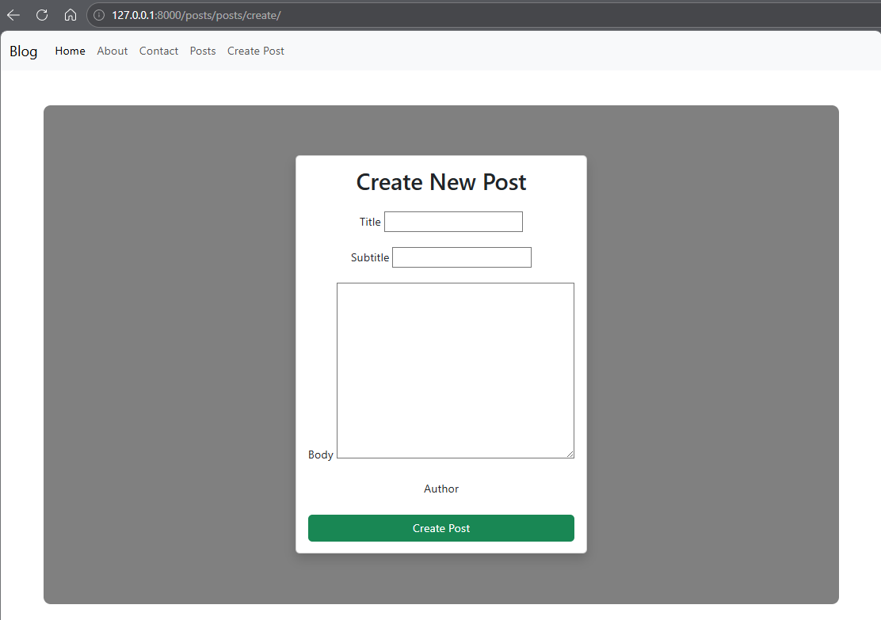

View w/ Option to Edit or Delete
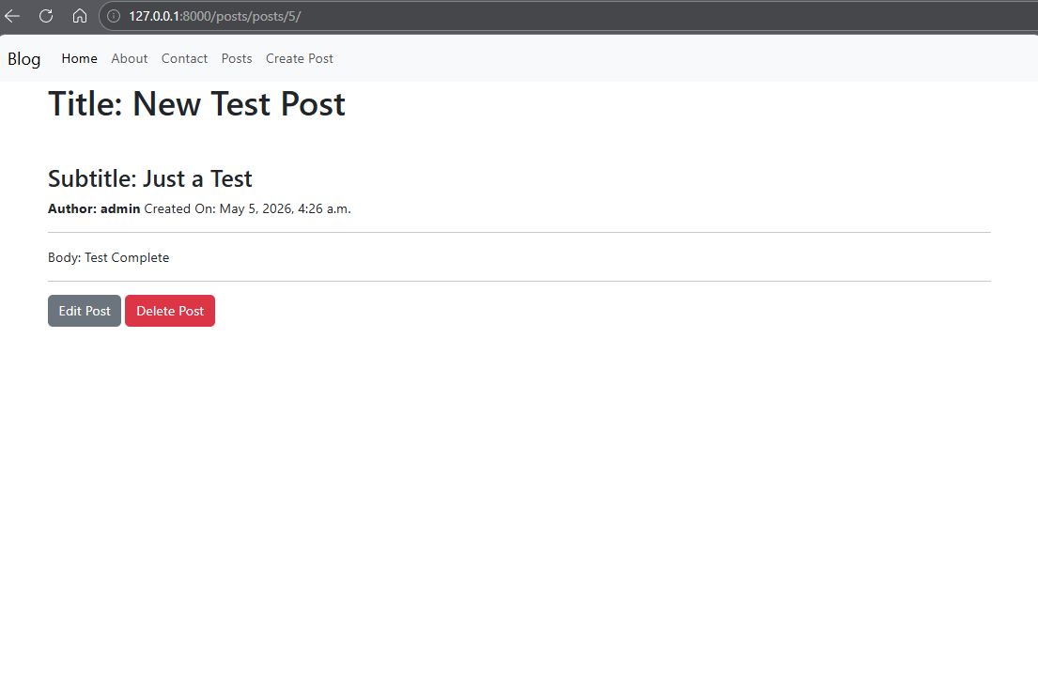
Sample Page rendered:

Retrospective
1.Which part of the project was the most difficult or challenging for you, and why?
This project itself was very difficult. There are a lot of steps and attention to detail involved with creating each page. After the pages were finished, I used AI to help generate inline notes for most of the pages, just because it was very difficult to keep up and take quality notes at the same time. This was a lot of new information, hopefully we will stay with this topic a little bit longer in the overall course, it seems very beneficial as a skill.
2. What did you enjoy the most or learn the most from while working on this project, and why? I enjoyed learning a new way to build a site, Django seems that it will take a lot of practice and repetition to get all the steps down. Once you have the steps down, it seems like Django might be the best framework that we have learned, everything is very streamlined, eliminating the need for a lot of extra code. But mastering the basics will be a challenge.

AI Disclosure (Required) – Highlight the one that applies
- I did not use AI
- I used AI for help
- AI generated parts of my code (if it’s the case, provide an explanation of the code in your own words).

